UEFA ELITE SCOUT PROGRAMME – Participant
On the UEFA elite scout programme, I was amongst some of the most talented scouts and sporting directors in the game and who’s knowledge and expertise where excellent to learn and gain experience from this included Andre villas-Boas former Porto Chelsea and Tottenham manager and Frederic Massara former AC Milan sporting director we discussed all sides and factors of scouting and recruitment.

Derry City FC – Goalkeeping Performance analyst and Recruitment
Video training sessions and matches then using it for Data Collection and performance analysis to which I speak with the goalkeeper coach about, also maintain live and regularly updated lists for potential replacement goalkeepers.
Omonia Nicosia & Trabzonspor – Consulting.
Given scouting reports and inside knowledge on the UK market regarding players that the clubs had an interest in pursuing.
Crewe Alexandra FC – First Team Live & Video Scout.
I scout for the first team covering all positions via live scouting and video scouting and then submitting my reports to the head of recruitment and first team management, I am also a key part of the goalkeeper selection process. I do data collection for position specific profiling as well.
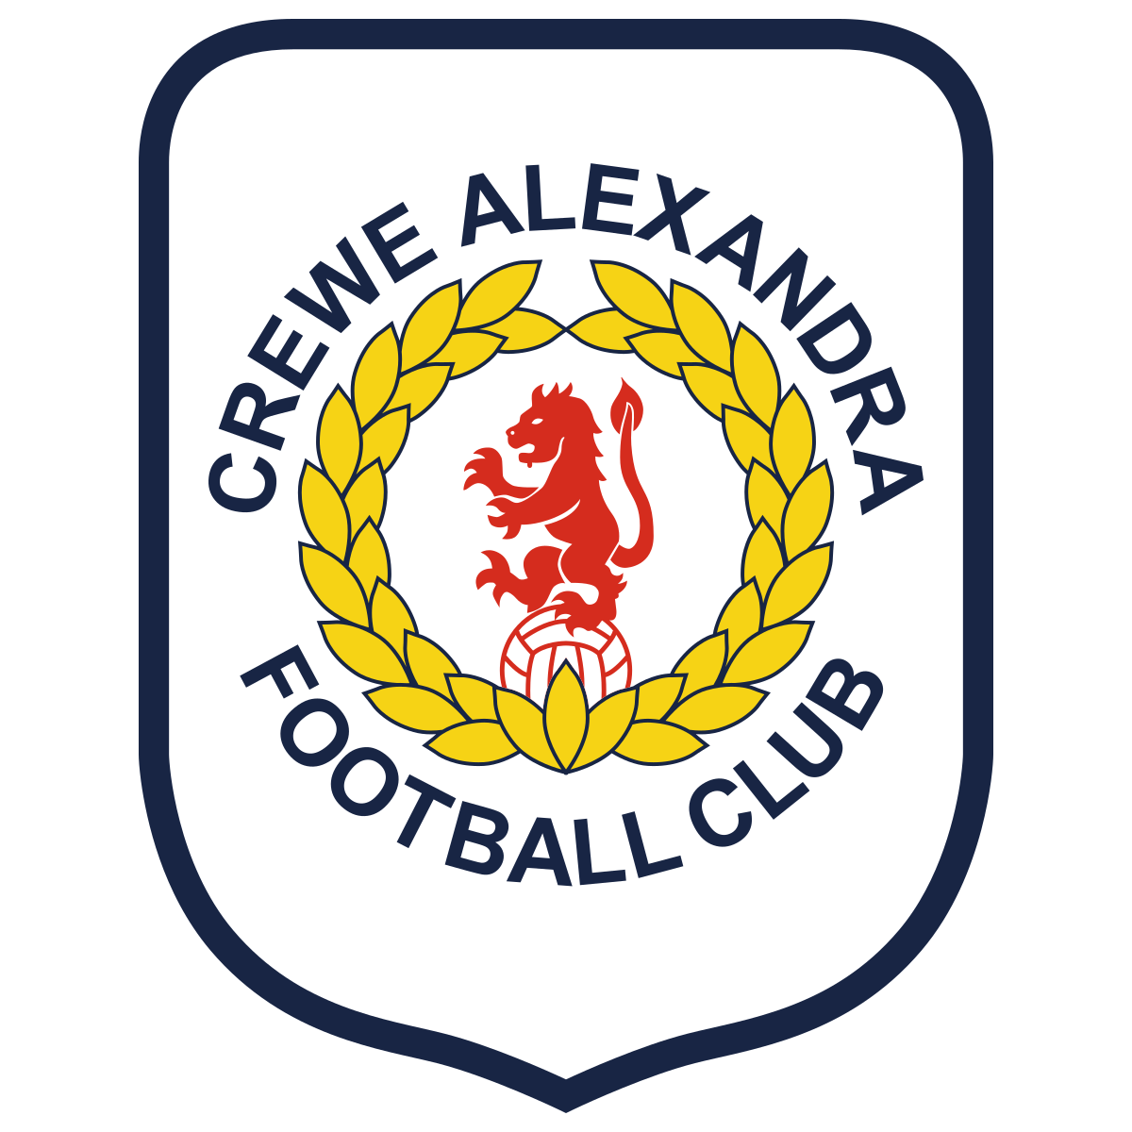
Scouting and Analyst Experience
UEFA Elite Scout Programme, diploma in Elite Football Scouting.
PFSA Level 1in Technical Scouting in Football
PFSA Level 2 in Technical Scouting in Football
PFSA Level 1 in Performance Analysis in Football
PFSA Level 2 in Performance Analysis in Football
PFSA Level 1 in Data Analysis in Football
PFSA Level 1 in Talent Identification in Football
PFSA Level 1 in Opposition Analysis in Football
PFA Analytics FC – Data Analytics Diploma
Applied Football Studies, Business in sport 2.1 BSC HONS
The FA level 1 intro to Talent ID
The FA respect for coaches
The FA disability football introduction
Scottish FA (SFA) mental health in football
Scottish FA (SFA) children’s wellbeing in football
Scottish FA (SFA) Goalkeeper award
Scottish FA (SFA) Goalkeeping level 1.2
Scottish FA (SFA) Goalkeeping 1.3
Scottish FA (SFA) Talent ID Award MCQ Exam
Football Qualifications
Working in Scouting and Analysis at first team level in The English Football league and Irish Football League, analysing players putting reports together on their performance and saying how they will fit into systems, how they can improve by seeing the current ability and future potential, then relaying the information I have found on them alongside the report and presenting to the Head of recruitment and manager on the player.
I have experience of both elite sports, and of working away from the sporting environment – having demonstrated resilience and adaptability as key attributes, whilst transitioning from a full-time professional playing career to one in working full-time in engineering and then moving into the finance industry.
Professional First Team Football Scout &
Performance Analyst specializing in Goalkeeping.
London, England
T: 07730670858
E: creano83@outlook.com
Alexander Crean

Professional Goalkeeper @ Arsenal Football Club (English Premier League) Sept 2016 – July 2018
Contracted Goalkeeper @ Bromley Football Club (National League) Jan 2016 - June 2016
Professional Goalkeeper @ Celtic Football Club (Scottish Premier League) July 2015 – Nov 2015
Playing Career
Goalkeeping, football, sport in general and keeping fit.
Golf.
Tiling.
Age 24 Years
Date of Birth 22nd August 1999
Clean Driving License.

LinkedIn Link - Link to LinkedIn Profile – https://www.linkedin.com/in/alex-crean-368758205/

Personal Information and Hobbies
Les Reed – former Sporting director at Southampton FC and manager of Charlton Athletic FC.
Colin Meldrum – Head of Celtic FC academy goalkeeping.
Josh Kinnard – Head of recruitment at Crewe Alexandra FC.
Oguzhan Kutlu – Senior First Team Scout at Trabzonspor FC.
References on Request
First-hand experience and knowledge of English Academy System, having been a player at Crystal Palace FC and Arsenal FC.
Provided coaching support to younger Academy goalkeepers at Crystal Palace, Celtic FC and Arsenal FC.
Worked with Academy Team Managers and provided support for younger Academy teams at Arsenal FC on match days.
Familiar with the Performance Management Application (PMA) process used at Academies by players and staff.
Familiar with key football Academy areas such as EPPP and also the conditioning and development of young players.
Leadership and coaching and working with players to achieve the best they can be.
Represented Scotland Youth u16 football Team.
Represented Arsenal FC Reserves, Celtic FC Reserves and Crystal Palace FC Academy Football Teams.
Bromley Football Club 1st Team Player in National League @ age 16 years.
Captained Crystal Palace and Celtic FC Academy teams and provided leadership, direction and support to all teams.
Have strong IT skills: IT Literate
Creative in digital design with good understanding of social media & networking sites
Ability to take on board information and understand and implement coaching strategies through playing career and now to provide strategies to players.
Learning Spanish through the PFA to broaden knowledge and also given the international nature of football.
The use of Wyscout and Impect for data analysis, filtration and recruitment of football players.
Key Skills, Representative achievements & Knowledge
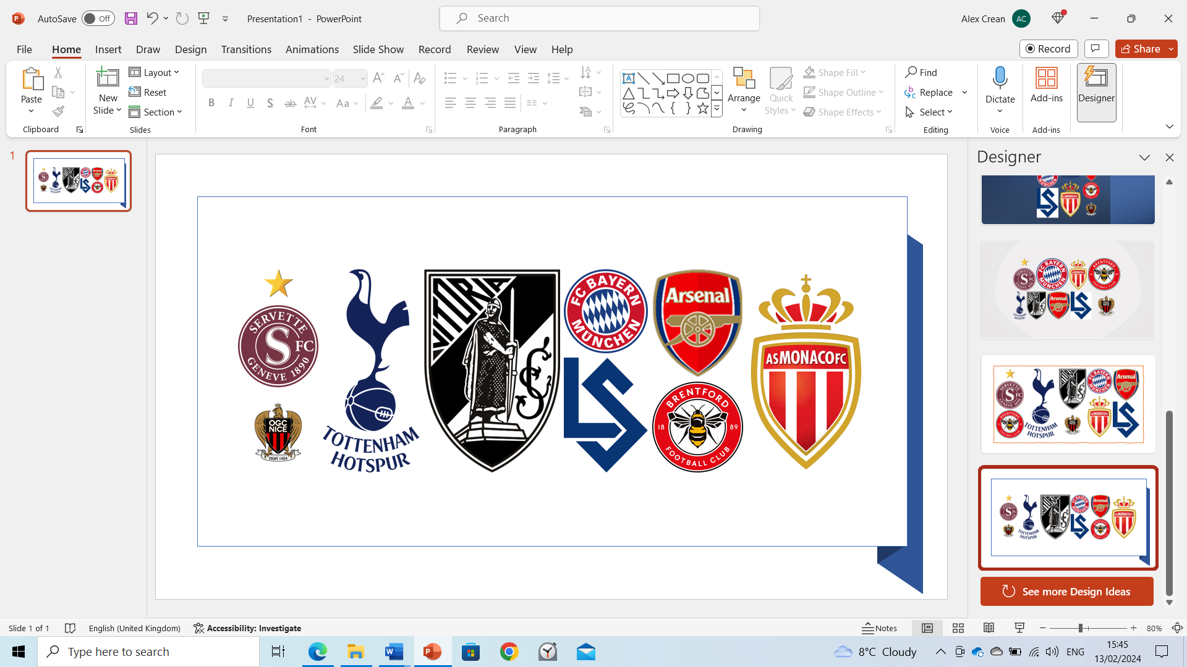

Lausanne FC – 2023
Servette FC – 2023
Brentford FC – 2023
Tottenham Hotspurs FC – 2023
Arsenal FC – 2023
FC Bayern München – 2023
OGC Nice – 2023
AS Mónaco – 2023
SC Vitoria Guimarães – 2023

Club Visits

